***STYLO SALON & SPA***

***Project By:***

***Palak Jain***

***ACKNOWLEDGMENT***

*I would like to express my special thanks of gratitude to my computer science teacher Mr. Arun Khanna for their able guidance and support in completing our project.*

*I would also like to extend my gratitude to the Principal ma’am Dr. Bhavna Malik and Incharge sir Mr. Naveen Chauhan for providing me with all the facilities that was required.*

*Last but not the least I would also like to thanks my companions for their immense support and understanding.*

***INDEX***

|  |  |  |
| --- | --- | --- |
| ***S.No*** | ***Topic*** | ***Page No.*** |
| ***1.*** | ***Introduction*** | ***4*** |
| ***2.*** | ***Database & Table Creation Coding*** | ***5-6*** |
| ***3.*** | ***Source Code for Python & MySQL Connectivity*** | ***7-29*** |
| ***4.*** | ***Output*** | ***30-39*** |

***INTRODUCTION***

*Salon and beauty parlour services at home with* ***Stylo Salon And Spa*** *app. This app helps you to discover the best beauty professionals near your home. The main objective of this app is to save time and complexity of work at beauty salon. This is a very much effective application. It is helpful for all the person because the use of application are easy. By this you can see all type of services for yourself, parlour work and get appointment according to your need. This app is available for booking your order anytime and anywhere and use the mode of online payment or cash payment.*

*There are more objectives for our salon app :-*

* *To manage the account of customers and salon owners*
* *Development of an application for salons to manage their daily schedules*
* *To evaluate best solution for booking appointments and manage the same.*
* *To offer services such as facial, cleanup, bleach, haircut, hair styling, hair colouring, manicure, massage, pedicure, bridal make up, make over, hair spa etc.*

***Database and table creation coding:***

import mysql.connector

mydb=mysql.connector.connect(host="localhost",user="root",passwd="")

mycursor=mydb.cursor()

mycursor.execute("create database stylo")

#table 1 : employee

import mysql.connector

mydb=mysql.connector.connect(host="localhost",user="root",passwd="",db="stylo")

mycursor=mydb.cursor()

mycursor.execute("create table employee(employee_id VARCHAR(50),name VARCHAR(50),phone_no VARCHAR(12),salary VARCHAR(10),address VARCHAR(100))")

# table 2 : client profile

import mysql.connector

mydb=mysql.connector.connect(host="localhost",user="root",passwd="",db="stylo")

mycursor=mydb.cursor()

mycursor.execute("create table client_profile(name VARCHAR(50),phone_no VARCHAR(12),treatment VARCHAR(50),amount VARCHAR(10))")

#table 3 : packages

import mysql.connector

mydb=mysql.connector.connect(host="localhost",user="root",passwd="",db="stylo")

mycursor=mydb.cursor()

mycursor.execute("create table packages(sno VARCHAR(10),package_name VARCHAR(50),amount VARCHAR(10))")

#table 4 : appointments

import mysql.connector

mydb=mysql.connector.connect(host="localhost",user="root",passwd="",db="stylo")

mycursor=mydb.cursor()

mycursor.execute("create table appointments(name VARCHAR(50),phone_no VARCHAR(12), scheduled_date VARCHAR(50),time VARCHAR(10))")

# table 5 : products for sale

import mysql.connector

mydb=mysql.connector.connect(host="localhost",user="root",passwd="",db="stylo")

mycursor=mydb.cursor()

mycursor.execute("create table products_for_sale(product_name VARCHAR(50),quantity VARCHAR(10),amount VARCHAR(50),expiry_date VARCHAR(50))")

***Source Code:***

print("***************************** Stylo Salon & Spa ***************************** ")

a='b'

while(a=='b'):

print('1.employee')

print('2.client profile')

print('3.packages')

print('4.appointments')

print('5.product for sale')

print('6.exit')

print("\n")

sel=int(input('enter the number:'))

if sel==1:

def emp():

print('1.add')

print('2.update')

print('3.display')

print('4.search')

print('5.delete')

print('6.main menu')

c=int(input("enter any number"))

if c==1:

addemp()

if c==2:

upemp()

if c==3:

disemp()

if c==4:

searchemp()

if c==5:

delemp()

else :

print('returning to main menu')

def addemp():

import mysql.connector

try:

mydb=mysql.connector.connect(host="localhost",user="root",passwd="",db="stylo")

mycursor=mydb.cursor()

id=input('enter employee_id')

name=input('enter employee name')

no=input('enter phone no.')

salary=input('enter salary')

address=input('enter address')

mycursor.execute("""insert into employee(employee_id,name,phone_no,salary,address)values(%s,%s,%s,%s,%s)""",(id,name,no,salary,address))

mydb.commit()

print("record inserted")

except Exception as e:

print(e)

print("unable to add record,plz try again")

def upemp():

import mysql.connector

try:

mydb=mysql.connector.connect(host="localhost",user="root",passwd="",db="stylo")

mycursor=mydb.cursor()

i=input('enter employee_id')

print("new data")

v=input('enter employee id')

w=input('enter employee name')

x=input('enter phone no')

y=input('enter salary')

z=input('enter address')

up=("update employee set employee_id=%s,name=%s,phone_no=%s,salary=%s,address=%s where employee_id=%s")

data=(v,w,x,y,z,i)

mycursor.execute(up,data)

print("record updated")

mydb.commit()

except:

print("unable to update record,plz try again")

def disemp():

import mysql.connector

from tabulate import tabulate

try:

mydb=mysql.connector.connect(host="localhost",user="root",passwd="",db="stylo")

mycursor=mydb.cursor()

mycursor.execute("select*from employee")

results=mycursor.fetchall()

print(tabulate(results,headers=["employee_id","name","phone_no","salary","address"],tablefmt="grid"))

print("record displayed")

except:

print("unable to display, plz try again")

def searchemp():

import mysql.connector

from tabulate import tabulate

try:

mydb=mysql.connector.connect(host="localhost",user="root",passwd="",db="stylo")

mycursor=mydb.cursor()

s=input('enter employee id')

st=("select * from employee where employee_id='%s'"%(s))

mycursor.execute(st)

results=mycursor.fetchall()

print(tabulate(results,headers=["employee_id","name","phone_no","salary","address"],tablefmt="grid"))

print('record displayed')

except:

print("unable to display,plz try again")

def delemp():

import mysql.connector

try:

mydb=mysql.connector.connect(host="localhost",user="root",passwd="",db="stylo")

mycursor=mydb.cursor()

i=input('employee id')

e="delete from employee where employee_id='%s'"%i

mycursor.execute(e)

mydb.commit()

print("record deleted")

except:

print("unable to delete,plz try again")

emp()

if sel==2:

def cp():

print('1.add')

print('2.update')

print('3.display')

print('4.search')

print('5.delete')

print('6.main menu')

f=int(input("enter any number"))

if f==1:

addcp()

if f==2:

upcp()

if f==3:

discp()

if f==4:

searchcp()

if f==5:

delcp()

else:

print('returning to the main menu')

def addcp():

import mysql.connector

try:

mydb=mysql.connector.connect(host="localhost",user="root",passwd="",db="stylo")

mycursor=mydb.cursor()

name=input('enter name of client')

no=input('enter phone number of client')

treatment=input('enter treatment of client')

amount=input('enter amount of treatment')

mycursor.execute("""insert into client_profile(name,phone_no,treatment,amount)values(%s,%s,%s,%s)""",(name,no,treatment,amount))

mydb.commit()

print("record inserted")

except Exception as e:

print(e)

print("unable to add record,plz try again")

def upcp():

import mysql.connector

try:

mydb=mysql.connector.connect(host="localhost",user="root",passwd="",db="stylo")

mycursor=mydb.cursor()

i=input('enter phone_no')

print("new data")

v=input('enter name of client')

w=input('enter phone_no')

x=input('enter treatment')

y=input('enter amount')

up=("update client_profile set name=%s,phone_no=%s,treatment=%s,amount=%s where phone_no=%s")

data=(v,w,x,y,i)

mycursor.execute(up,data)

print("record updated")

mydb.commit()

except:

print("unable to update record,plz try again")

def discp():

import mysql.connector

from tabulate import tabulate

try:

mydb=mysql.connector.connect(host="localhost",user="root",passwd="",db="stylo")

mycursor=mydb.cursor()

mycursor.execute("select * from client_profile")

results=mycursor.fetchall()

print(tabulate(results,headers=["name of client","phone_no","treatment","amount"],tablefmt="grid"))

print("record displayed")

except:

print("unable to display, plz try again")

def searchcp():

import mysql.connector

from tabulate import tabulate

try:

mydb=mysql.connector.connect(host="localhost",user="root",passwd="",db="stylo")

mycursor=mydb.cursor()

s=input('enter phone_no')

st=("select * from client_profile where phone_no='%s'"%(s))

mycursor.execute(st)

results=mycursor.fetchall()

print(tabulate(results,headers=["name of client","phone_no","treatment","amount"],tablefmt="grid"))

print('record displayed')

except:

print("unable to display,plz try again")

def delcp():

import mysql.connector

try:

mydb=mysql.connector.connect(host="localhost",user="root",passwd="",db="stylo")

mycursor=mydb.cursor()

i=input('phone_no')

e="delete from client_profile where phone_no='%s'"%i

mycursor.execute(e)

mydb.commit()

print("record deleted")

except:

print("unable to delete,plz try again")

cp()

if sel==3:

def pak():

print('1.add')

print('2.update')

print('3.display')

print('4.modify')

print('5.delete')

print('6.main menu')

g=int(input("enter number"))

if g==1:

addpak()

if g==2:

uppak()

if g==3:

dispak()

if g==4:

searchpak()

if g==5:

delpak()

else:

print('returning to main menu')

def addpak():

import mysql.connector

try:

mydb=mysql.connector.connect(host="localhost",user="root",passwd="",db="stylo")

mycursor=mydb.cursor()

no=input('enter sno')

name=input('enter package name')

amount=input('enter amount')

mycursor.execute("""insert into packages(sno,package_name,amount)values(%s,%s,%s)""",(no,name,amount))

mydb.commit()

print("record inserted")

except Exception as e:

print(e)

print("unable to add record,plz try again")

def uppak():

import mysql.connector

try:

mydb=mysql.connector.connect(host="localhost",user="root",passwd="",db="stylo")

mycursor=mydb.cursor()

i=input('enter sno')

print("new data")

v=input('enter sno')

w=input('enter package name')

x=input('enter amount')

up=("update packages set sno=%s,package name=%s,amount=%s where sno=%s")

data=(v,w,x,i)

mycursor.execute(up,data)

print("record updated")

mydb.commit()

except:

print("unable to update record,plz try again")

def dispak():

import mysql.connector

from tabulate import tabulate

try:

mydb=mysql.connector.connect(host="localhost",user="root",passwd="",db="stylo")

mycursor=mydb.cursor()

mycursor.execute("select * from packages")

results=mycursor.fetchall()

print(tabulate(results,headers=["sno","package name","amount"],tablefmt="grid"))

print("record displayed")

except:

print("unable to display, plz try again")

def searchpak():

import mysql.connector

from tabulate import tabulate

try:

mydb=mysql.connector.connect(host="localhost",user="root",passwd="",db="stylo")

mycursor=mydb.cursor()

s=input('enter sno')

st=("select * from packages where sno='%s'"%(s))

mycursor.execute(st)

results=mycursor.fetchall()

print(tabulate(results,headers=["sno","package name","amount"],tablefmt="grid"))

print('record displayed')

except:

print("unable to display,plz try again")

def delpak():

import mysql.connector

try:

mydb=mysql.connector.connect(host="localhost",user="root",passwd="",db="stylo")

mycursor=mydb.cursor()

i=input('sno')

e="delete from packages where sno='%s'"%i

mycursor.execute(e)

mydb.commit()

print("record deleted")

except:

print("unable to delete,plz try again")

pak()

if sel==4:

def app():

print('1.add')

print('2.update')

print('3.display')

print('4.search')

print('5.delete')

print('6.main menu')

h=int(input('enter number'))

if h==1:

addapp()

if h==2:

upapp()

if h==3:

disapp()

if h==4:

searchapp()

if h==5:

delapp()

else:

print('returning to the main menu')

def addapp():

import mysql.connector

try:

mydb=mysql.connector.connect(host="localhost",user="root",passwd="",db="stylo")

mycursor=mydb.cursor()

name=input('enter name of client')

no=input('enter phone_no')

date=input('enter scheduled_date')

time=input('enter time')

mycursor.execute("""insert into appointments(name,phone_no,scheduled_date,time)values(%s,%s,%s,%s)""",(name,no,date,time))

mydb.commit()

print('record inserted')

except Exception as e:

print(e)

print("unable to add record,plz try again")

def upapp():

import mysql.connector

try:

mydb=mysql.connector.connect(host="localhost",user="root",passwd="",db="stylo")

mycursor=mydb.cursor()

i=input('enter phone_no')

print("new data")

v=input('enter name of client')

w=input('enter phone_no')

x=input('enter scheduled_date')

y=input('enter time')

up=("update appointments set name=%s,phone_no=%s,scheduled_date=%s,time=%s where phone_no=%s")

data=(v,w,x,y,i)

mycursor.execute(up,data)

print("record updated")

mydb.commit()

except:

print("unable to update record,plz try again")

def disapp():

import mysql.connector

from tabulate import tabulate

try:

mydb=mysql.connector.connect(host="localhost",user="root",passwd="",db="stylo")

mycursor=mydb.cursor()

mycursor.execute("select * from appointments")

results=mycursor.fetchall()

print(tabulate(results,headers=["name of client","phone_no","scheduled_date","time"],tablefmt="grid"))

print("record displayed")

except:

print("unable to display, plz try again")

def searchapp():

import mysql.connector

from tabulate import tabulate

try:

mydb=mysql.connector.connect(host="localhost",user="root",passwd="",db="stylo")

mycursor=mydb.cursor()

s=input('enter sno')

st="select * from appointments where sno='%s'"%(s)

mycursor.execute(st)

results=mycursor.fetchall()

print(tabulate(results,headers=["name of client","phone_no","scheduled_date","time"],tablefmt="grid"))

print('record displayed')

except:

print("unable to display,plz try again")

def delapp():

import mysql.connector

try:

mydb=mysql.connector.connect(host="localhost",user="root",passwd="",db="stylo")

mycursor=mydb.cursor()

i=input('sno')

e="delete from appointments where sno='%s'"%i

mycursor.execute(e)

mydb.commit()

print("record deleted")

except:

print("unable to delete,plz try again")

app()

if sel==5:

def prod():

print('1.add')

print('2.update')

print('3.display')

print('4.search')

print('5.delete')

print('6.main menu')

i=int(input('enter number'))

if i==1:

addprod()

if i==2:

upprod()

if i==3:

disprod()

if i==4:

searchprod()

if i==5:

delprod()

else:

print('returning to the main menu')

def addprod():

import mysql.connector

try:

mydb=mysql.connector.connect(host="localhost",user="root",passwd="",db="stylo")

mycursor=mydb.cursor()

name=input('enter product_name')

quantity=input('enter quantity')

amount=input('enter amount')

date=input('enter expiry_date')

mycursor.execute("""insert into products for sale(product_name,quantity,amount,expiry_date)values(%s,%s,%s,%s)""",(name,quantity,amount,date))

mydb.commit()

print('record inserted')

except Exception as e:

print(e)

print("unable to add record,plz try again")

def upprod():

import mysql.connector

try:

mydb=mysql.connector.connect(host="localhost",user="root",passwd="",db="stylo")

mycursor=mydb.cursor()

i=input('enter product_name')

print("new data")

v=input('enter product name')

w=input('enter quantity')

x=input('enter amount')

y=input('enter expiry_date')

up=("update products for sale set product_name=%s,quantity=%s,amount=%s,expiry_date=%s where product_name=%s")

data=(v,w,x,y,i)

mycursor.execute(up,data)

print("record updated")

mydb.commit()

except:

print("unable to update record,plz try again")

def disprod():

import mysql.connector

from tabulate import tabulate

try:

mydb=mysql.connector.connect(host="localhost",user="root",passwd="",db="stylo")

mycursor=mydb.cursor()

mycursor.execute("select * from products for sale")

results=mycursor.fetchall()

print(tabulate(results,headers=["product name","quantity","amount","expiry date"],tablefmt="grid"))

print("record displayed")

except:

print("unable to display, plz try again")

def searchprod():

import mysql.connector

from tabulate import tabulate

try:

mydb=mysql.connector.connect(host="localhost",user="root",passwd="",db="stylo")

mycursor=mydb.cursor()

s=input('enter product_name')

st="select * from products for sale where product_name='%s'"%(s)

mycursor.execute(st)

results=mycursor.fetchall()

print(tabulate(results,headers=["product name","quantity","amount","expiry date"],tablefmt="grid"))

print('record displayed')

except:

print("unable to display,plz try again")

def delprod():

import mysql.connector

try:

mydb=mysql.connector.connect(host="localhost",user="root",passwd="",db="stylo")

mycursor=mydb.cursor()

i=input('product_name')

e="delete from products for sale where product_name='%s'"%i

mycursor.execute(e)

mydb.commit()

print("record deleted")

except:

print("unable to delete,plz try again")

prod()

if sel==6:

exit()

***Output:***

* ***Table 1: Employee***

1. ***To add record to the table.***

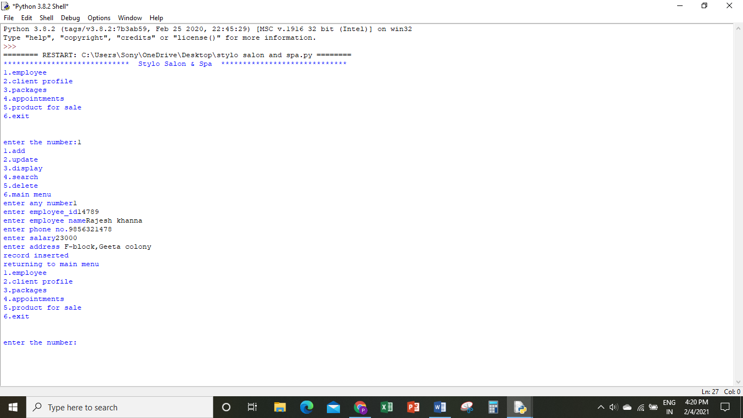

1. ***To update records of the table.***

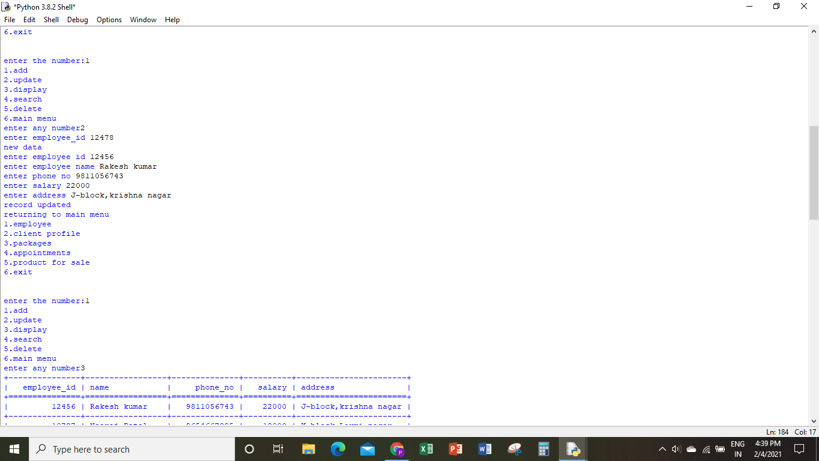

1. ***To display all the records of the table.***

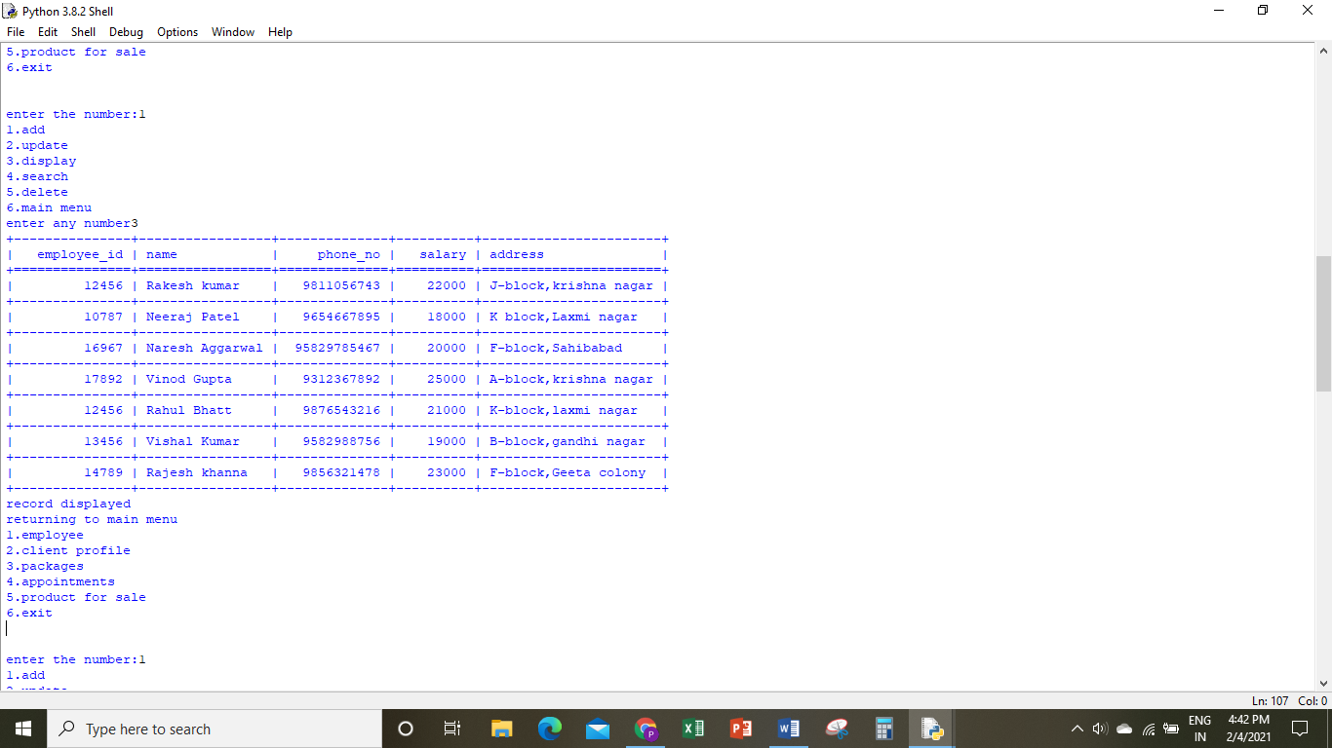

1. ***To search a record in a table.***

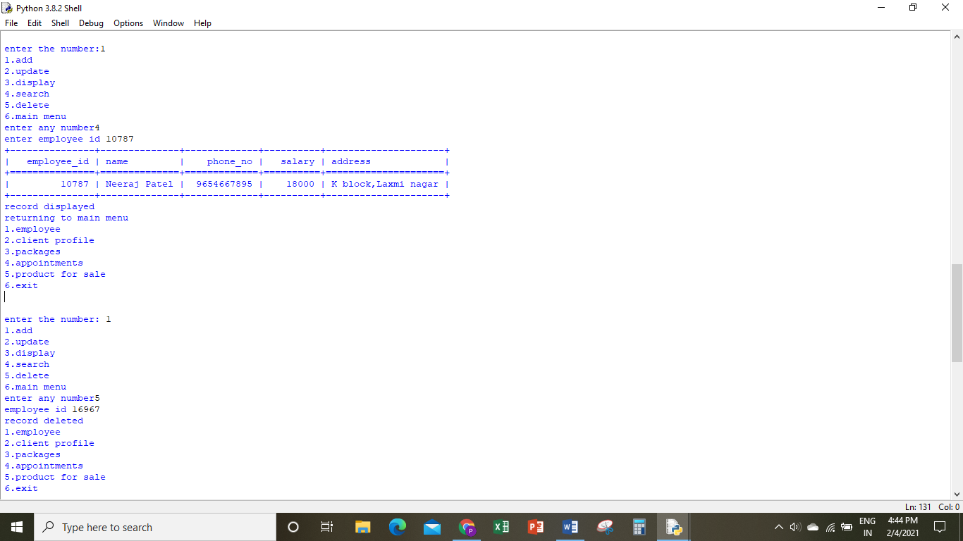

1. ***To delete a record from table.***

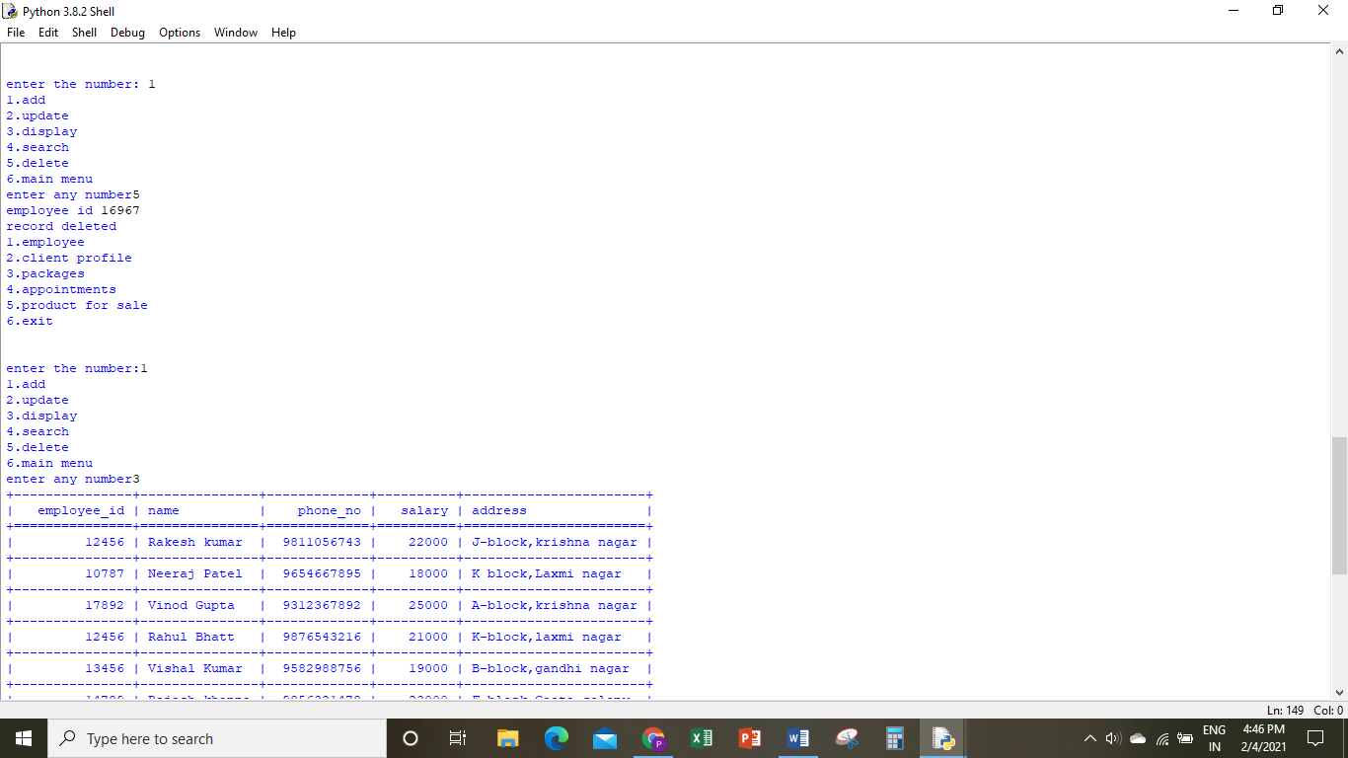

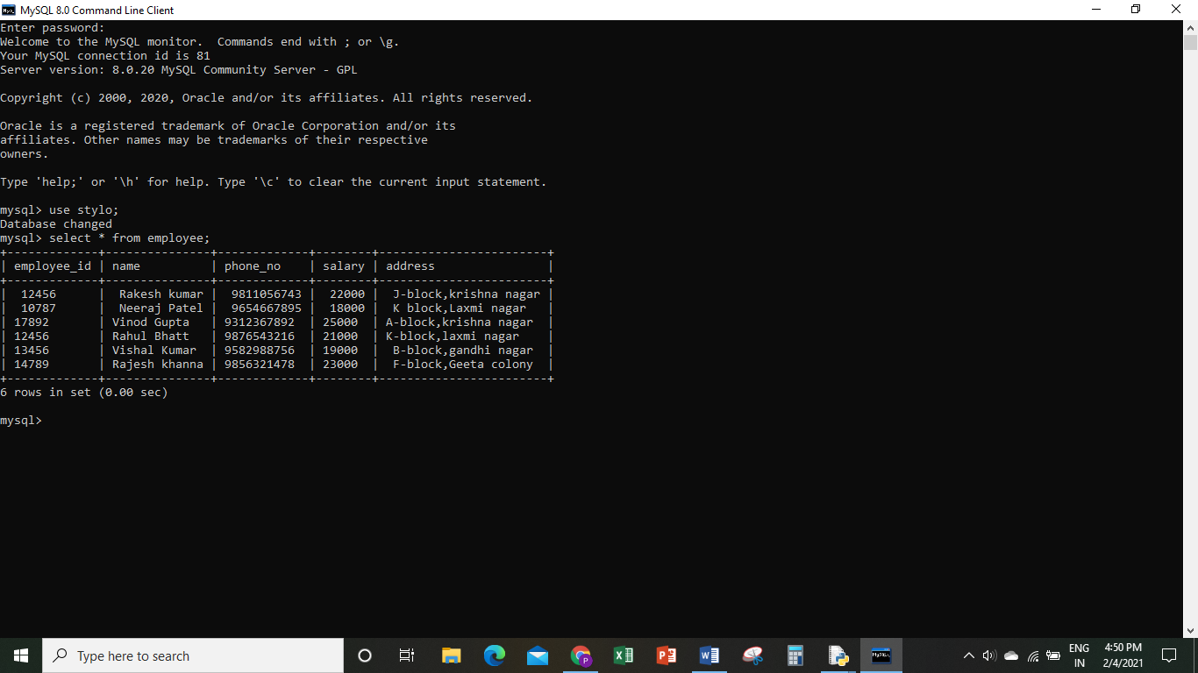

* ***Table 2: Client profile***

1. ***To add record to the table.***

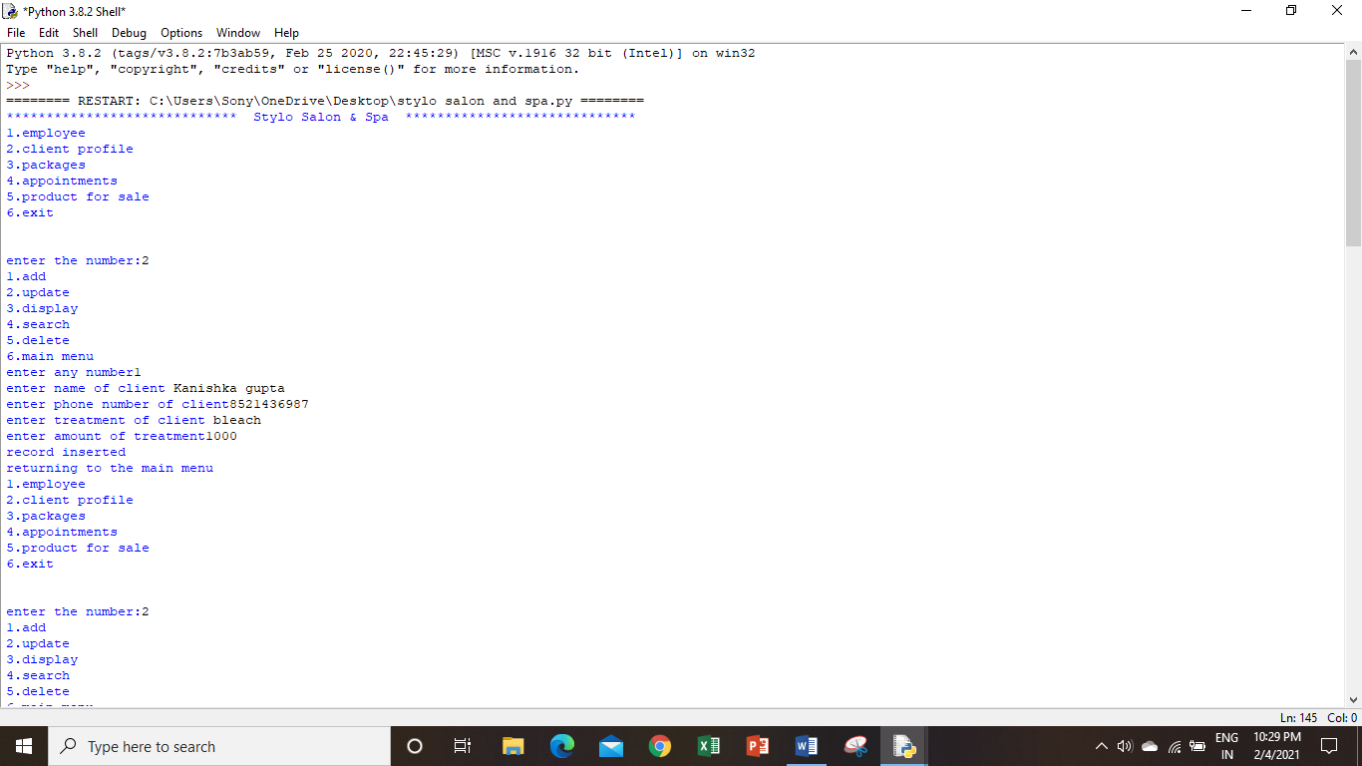

1. ***To update records of the table.***

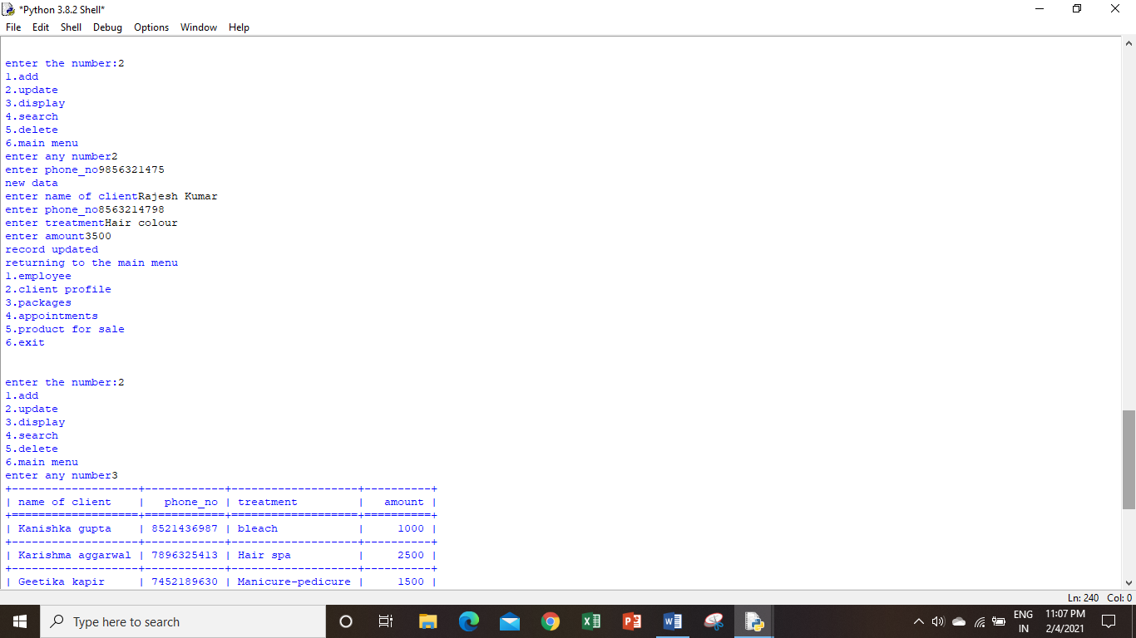

1. ***To display all the records of table.***

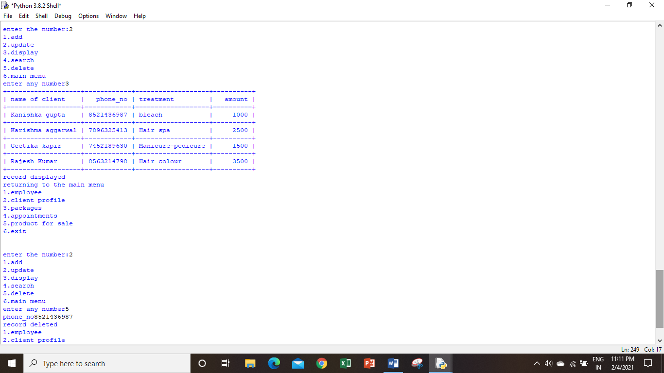

1. ***To search a record in a table.***

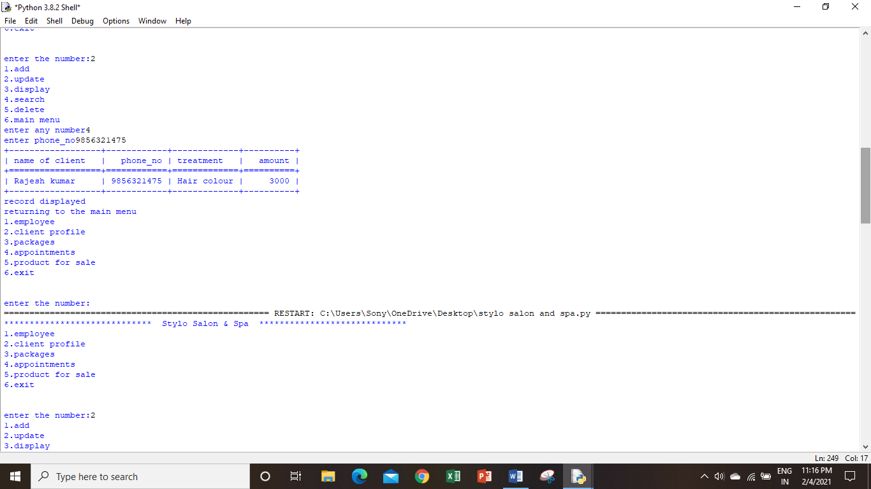

1. ***To delete a record from table.***

